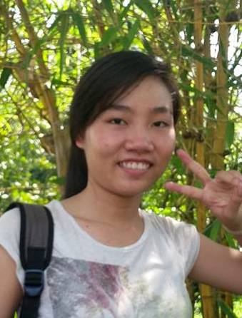 **Ho Thi Thanh Thao**

**Address**: BA2 Building, B Dormitory, Nation

University, HCM City

**Tel:** 0167 685 7350

**Email**: [thaoho21294@gmail.com](mailto:thaoho21294@gmail.com)

|  |
| --- |
| Career Objective |

* Become Back-end developer
* Put knowledge, experience and skills to efficient use.
* Get experiment in 2 years.
* Start a company after that.

|  |
| --- |
| Achievements |

* Get four encouraging scholarships at University (2013-2015).
* Be Five-Goodness Student in 2014s.

|  |
| --- |
| Education |

* Junior in Software Engineering Major at Information Technology University 2012 – 2015
* Grade: pretty good
* Time of graduation: 6/2016

|  |
| --- |
| Experience |

*Project I have done for studying*

|  |  |  |  |
| --- | --- | --- | --- |
| Time | Project Name | Technology | Language |
| 2015 | Kindergarten Management | Project 3-Layer | C# |
| 2014 | Bank Management Project | LinQ | C# |
| 2014 | Contra Game | DirectX 9 | C++ |

|  |
| --- |
| Skills |

* Technical:
* Software: Microsoft Office Package, ToitoiseSVN, Eclipse, VS.
* Others: Communication, Teamwork, Multitasking.

|  |
| --- |
| Foreign Language |

English Course at my school.

Grade: 7.0

|  |
| --- |
| Outdoor Activities |

* Join the English club that called E4F - English for Future at B Dormitory (National University Dormitory).
* Blood Donation Program (every year)
* Exam season supporting 2015

|  |
| --- |
| Hobbies |

Singing, talking English and creating and design software.

|  |
| --- |
| Reference |

References available upon request.